Statistics HW5 b03705002林軒逸

4.49

75mph. Since the 85th percentile is 75. (Calculate by PERCENTILE in excel)

4.53

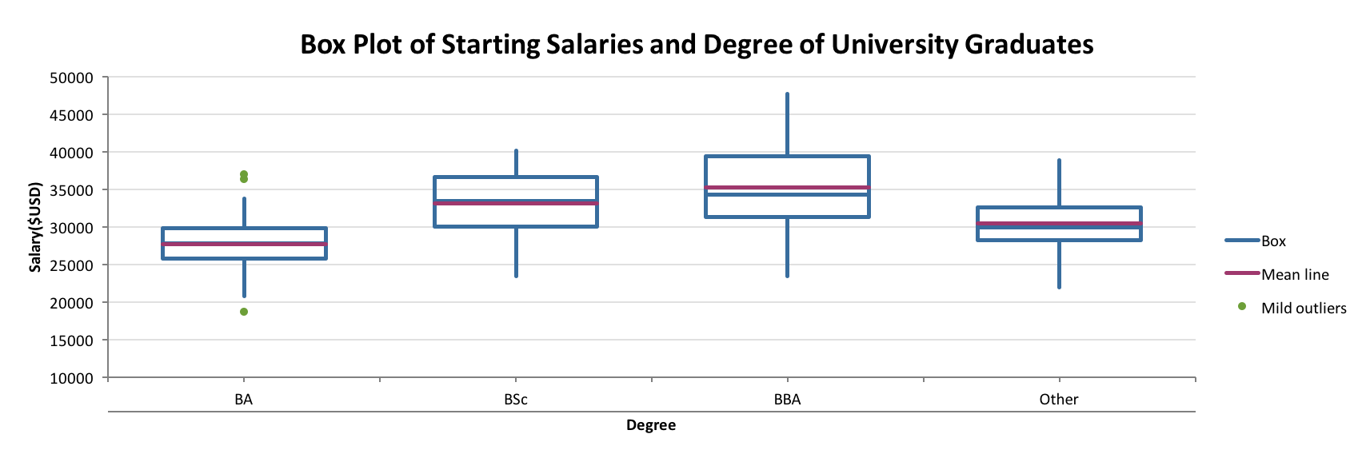

The box plot BA to BSc to BBA becomes higher and higher, and the range from Q1 to Q3 also becomes bigger. That is, BA’s salary interquartile range is smaller than the interquartile range of BSc, and the interquartile range of BSc is smaller than the one of BBA’s. Also, the median (Q2) is higher and higher from BA to BBA. Other is quite similar to BA, but we don’t know what Other is, so I have no comment on it.

4.56

a.

Q1=26

Q2=28.5

Q3=32

b.

The range of Q1 to Q2(2.5) is less than the range of Q2 to Q3(3.5), thus, we can assume that the histogram of this case is a little right-skewed.

4.67

Covariance:

Sxy= 287.8(The result of the sum of (Xi-Ux)(Yi-Uy))/11=26.1636364

Coefficient of correlation:

(Sxy/Sx\*Sy)= r = 26.1636364/(43.5621291\*1.11952371) = 0.53648269

Coefficient of determination:

r^2 = 0.28781367

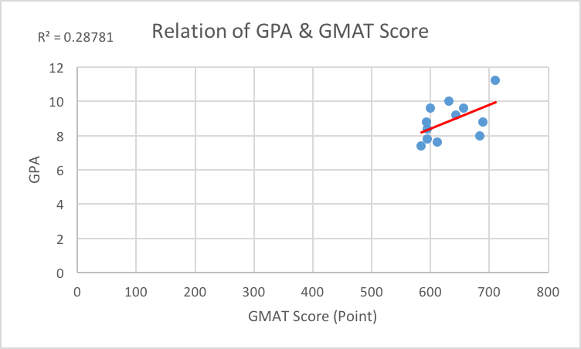

By the coefficient of correlation, we can see that it drops in 0.5 and 0.75. That is, GPA and GMAT Score has a quite good but not strong relationship. Also, by the coefficient of determination, we can know that 28.7% of the variation of GPA Scores is explained by GMAT Score, and 71.3% unexplained.

4.75

a.

Coefficient of Correlation: 0.274473

Coefficient of Determination:0.07535

b. 14771 tickets.

As we can see, the formula y=14771x + 1000000, which means the marginal number of tickets sold for each additional game won is 14771 (Attendance).

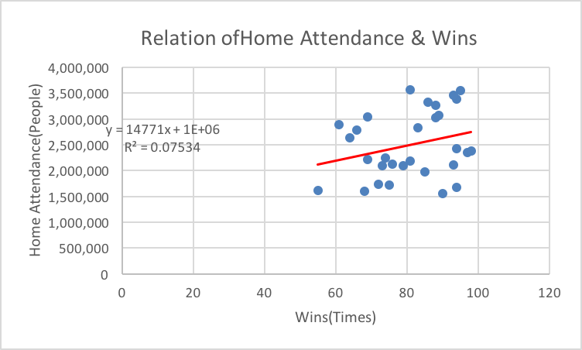

4.115

Coefficient of correlation: 0.966128

Coefficient of determination: 0.9334

These tells us that there is strong relationship between car speed and cost, and 93.3% of the variation in price can be explained by speed, and 6.7% unexplained.

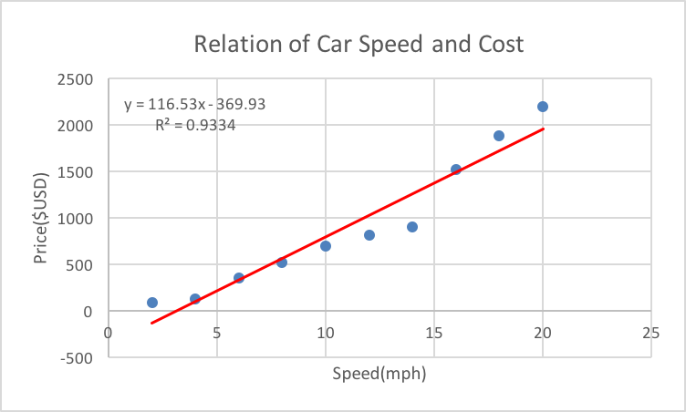

6.3

a. I suppose the multiple choices are A, B, C, D, E

S= {A, B, C, D, E}

b.

P(A)=0.2

P(B)=0.2

P(C)=0.2

P(D)=0.2

P(E)=0.2

c. Classical approach.

d. Since the students knows absolutely nothing, it means the five choices have the same probability. That is, 1/5=0.2.

6.7

a. 1-0.42=0.58

b. 0.09+0.22=0.31

c. 0.42+0.09+0.27=0.78

6.27

a.P(Promoted|Female)= 0.03/0.15 = 0.2

b.P(Promoted|Male)= 0.17/0.85= 0.2

c. No. Since the promoted rate in each gender is the same. The reason why the probability for male to promote is higher is just because there are more male in this workplace. Thus, it isn’t reasonable to accuse the university of gender bias.

6.37

a.P(Above average|Murderer)=0.27/0.48= 0.5625 (56.25%)

b. Take Exercise a as example, P(Above average| Murderer)=0.5625, and it isn’t equal to P(Above Average)=0.51. That is, levels of testosterone and crime committed aren’t independent.

6.43

a. 0.19+ 0.64= 0.83

b.P(Fully repaid|Under 400)=0.19/0.32=0.59

c.P(Fully repaid|400 or More)= 0.64/0.68=0.94

d. No. Take Exercise b,c as example,

P(Fully repaid|Under 400)=0.59 isn’t equal to P(Fully repaid)=0.83

P(Fully repaid|400 or More)=0.94 isn’t equal to P(Fully repaid)=0.83

That is, whether loan is fully repaid or not isn’t independent to score.